**TECHNICAL REPORT ON PROJECT 1.**

**BY**

**ADEGOKE BLESSING TUNMISE**

**VEPH/20B/DA189**

**Task 16B (i)**

**MOTUN GROUP OF COMPANY PERFROMANCE ANALYSIS FOR 2019**

OUTLINE

1.     Introduction

2.     Story of Data

3.     Data Splitting

4.     Pre-Analysis

5.     In-Analysis and Insights

6.     Data Visualization

7.     Recommendations and Observations

8.     Conclusion

**1. Introduction**

This report presents a detailed overview of Motun group of company sales performance and provides strategic insights to improve business operations in future financial years.

**2. Story of the data**

The data is obtained from a public dataset and tells a story of the Product quantity, Revenue generated, and the Shipping fee for some products fall under some product categories sold to some customers by different salespersons working for a firm in the USA situated at different regions. This data was gathered through an automated script process.

Data Structure: The data is a structured data arranged in a table with rows representing transactions and columns showing Customer Names, Order ID, Order Date, Region, Sales Persons, Ship Date, Zip/Postal code, Shipper Name, Ship Name.

**3.Data Splitting**

Data Cleaning:

In order to ensure cleanliness of the datasets, firstly, I removed the duplicated rows and ensure there is none blank rows. I also ensured the column headings are well spelt out and the whole dataset was converted to a normal Excel table for quick updating when needed.

Handling Missing Values:

·         Replacing missing values with the columns mean and mode for categorical data.

Data Transformations:

·         Adding new columns based on condition.

·         Reshaping wide data

Data Split: The data was split into two categories. Category one is the independent values while category two is the dependent value.

Category One - Independent values

Customer Name, Customer ID, Address, City, State, Country, Region, Sales Person, Shipper Name, Ship Name, Ship Address, Payment Type, Product Name.

Category Two - Dependent values

Order ID, Zip Code, Postal Code, Quantity, Revenue, Unit Price, Shipping Fee, Shipped Date

Industry context: The data is a retail data set and its analysis will help to improve sales in the coming year.

Stakeholder: C.E.O

What matters to the company: Getting more revenue in the subsequent year(s).

**4. Pre-Analysis and Intended Insights**

* I intend to determine the best performing region by the revenue generated.
* I intend to highlight the worst performing region by the revenue generated.
* I intend to determine the best performing salesperson by the revenue generated
* I intend to determine the worst performing salesperson by the revenue generated.
* I intend to determine the best performing category by the quantity sold.
* I intend to determine the top cities based on revenue.

**5. In-Analysis**

1. From the salesperson performance analysis, it was deduced that Nancy Freehafer is the best performing salesperson for the year 2014 with a grossing revenue of $104242.34

2. Also, Jan Kotas happened to be worst performing salesperson with the grossing revenue of $16,350.5.

3. From the Category performance analysis, Beverages happened to be the most sold product category for the year 2014 with total number of 5202 beverages sold.

4. Top 5 cities based on revenue generated are New York, Portland, Memphis, Milwaukee, and Salt Lake City

5. From the Region sales performance, North contributed most by generating the grossing revenue of $141660.34, while West contributed the least with the total sum of revenue of $91251.98.

6. The total sum of the revenue made for the year 2019 was $435036.16

7. Company D is observed to be the best customer for the year 2019

8. New York is observed to be the top ship city for the year 2019.

9. December sales is observed to be the best for the year 2019.

10. Products sold within the range of 0 to $1000 are the most purchased goods for the year with a total count of 218.

**6. DATA VISUALIZATION**

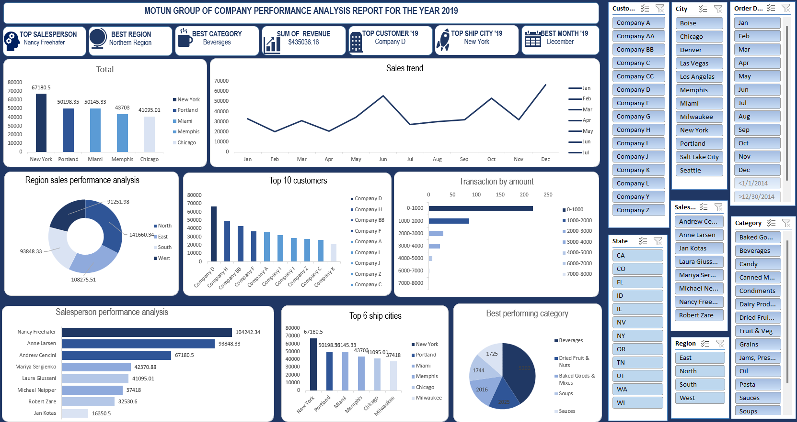

7. **Recommendations**:

1. Jan being the worst performing salesperson for the year 2019, I recommend to the stakeholders that he should be retrenched or sent over for some special trainings on sales and customer relation to ensure his performance for the next year improves.

2. New York being the top city with the highest amount of generated revenue and also the top ship city for the year 2019, I recommend to the stakeholders that a branch should be situated there to attract more customers and make buying easier for the customers in New York as the shipping fees could be used for buying more from us in the subsequent year(s).

3. For the company to make more revenue in the next year, I recommend to the stakeholders to come up with a discount or presenting an award with prize to Company D which happens to be our best customer for the year 2019. This would help the company to retain the customer's loyalty and make them want to buy more from us.

4. Lastly, the stakeholders should ensure the stock/inventory department does not allow beverages to finish before replenish as it is the fastest selling product category, especially the ones within the amount of 0 - $1000.

**8. Conclusion:**

This analysis provides insights into key salesperson performance, and product performance. By implementing the recommended strategies, the business can optimize revenue growth, improve market positioning, and enhance customer satisfaction.